**PROJECT -REPORT**

***THE VOYAGE VISTA ILUMINATING INSIGHTS FROM THE UBER EXPIDINARY***



TEAM ID(NM2023TMIDO6473)

TEAM MEMBERS:

Rajgowtham.D(asunm1319222104943)

JayaSeelan.M(asunm1319222104928)

Saran.T(asunm1319222104948)

Sachin.S(asunm1319222104945)

INTRODUCTION:

1.1: OVERVIEW

UBER Technologies Inc (UBER) is a provider of ride-hailing services. It offers services through its technology platforms such as mobile applications and websites. UBER connects riders with drivers or independent ride solution providers.

1.2: PURPOSE:

The UBER mission statement is “to provide transportation as reliable as running water, everywhere, for everyone.” And the UBER vision statement is “to ignite opportunity by setting the world in motion.”

* UBER is a transportation company with an app that allows passengers to hail a ride and drivers to charge fares and get paid. More specifically, UBER is a ride sharing company that hires independent contractors as drivers.

2.PROBLEM DEFINATION & DESIGN THINKING

2.1:EMPATHY MAP:

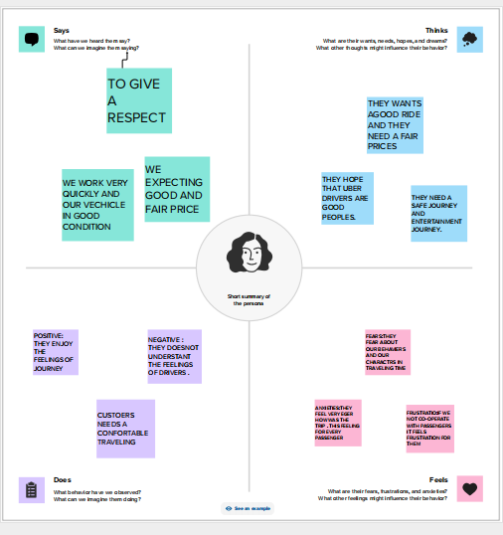

2.1: IDEATION&BRAINSTORME:

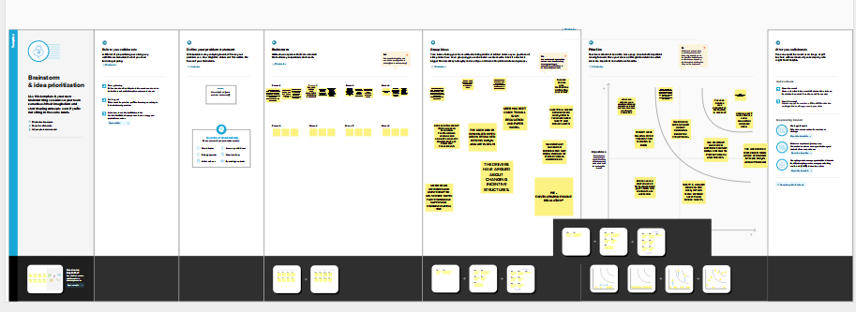

1. RESULT:

Using the tableau software we analysed the data set of UBER company and have created visualization.

1.purpose and miles of uber:

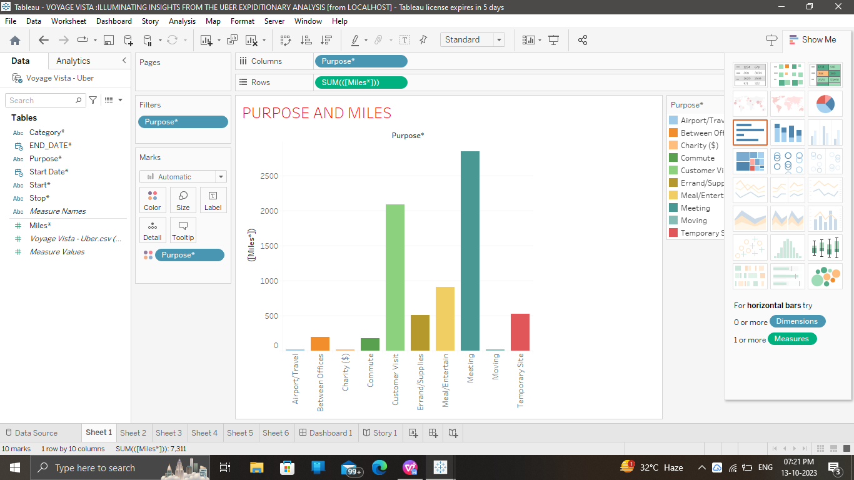

2.categary and purpose of miles:

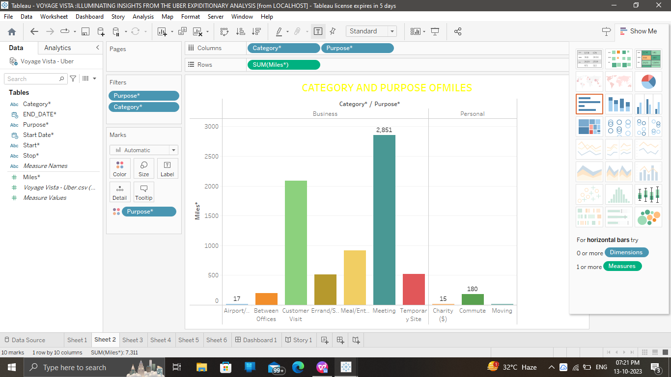

3.UBER work for maximum and minimum:

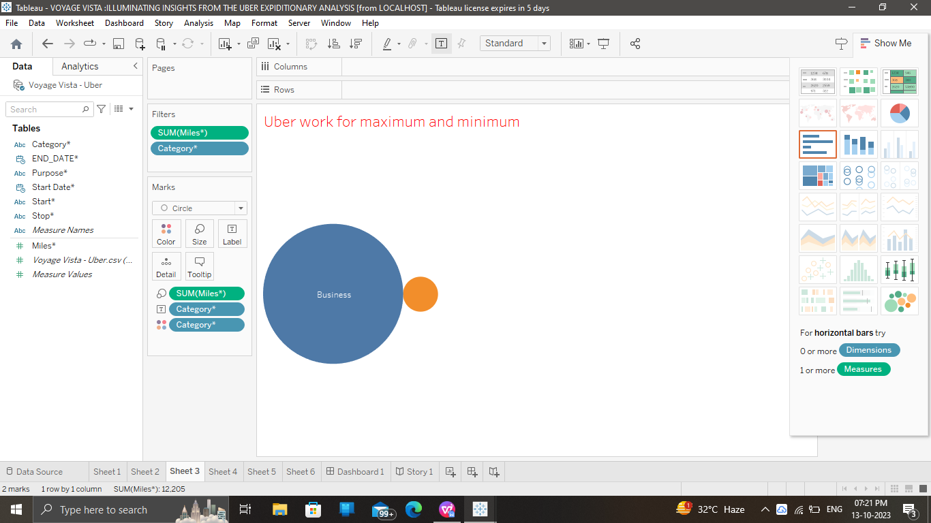

4.month wise miles covered:

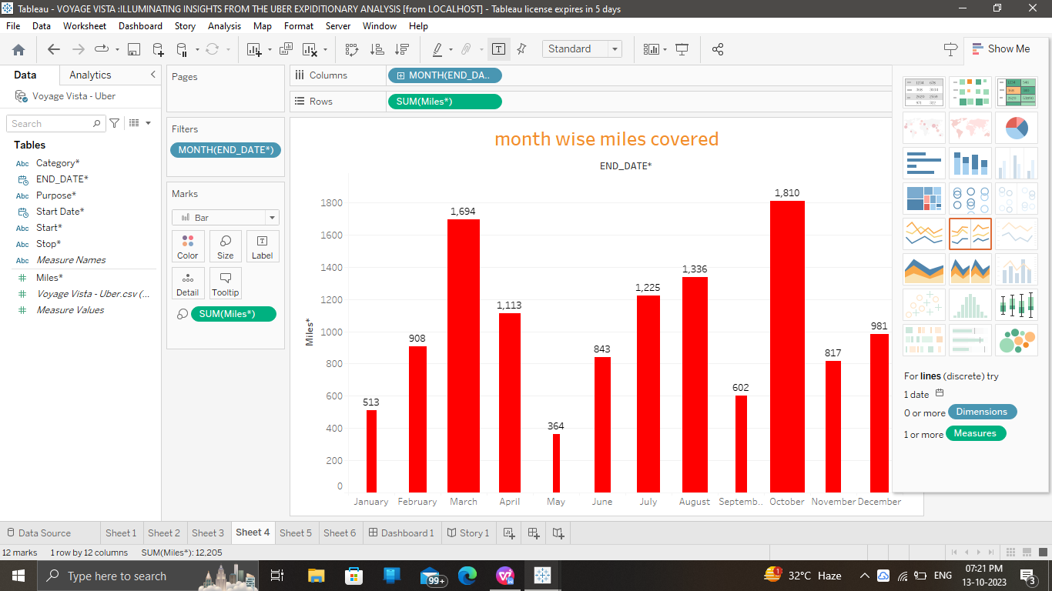

5.week wise miles covered:

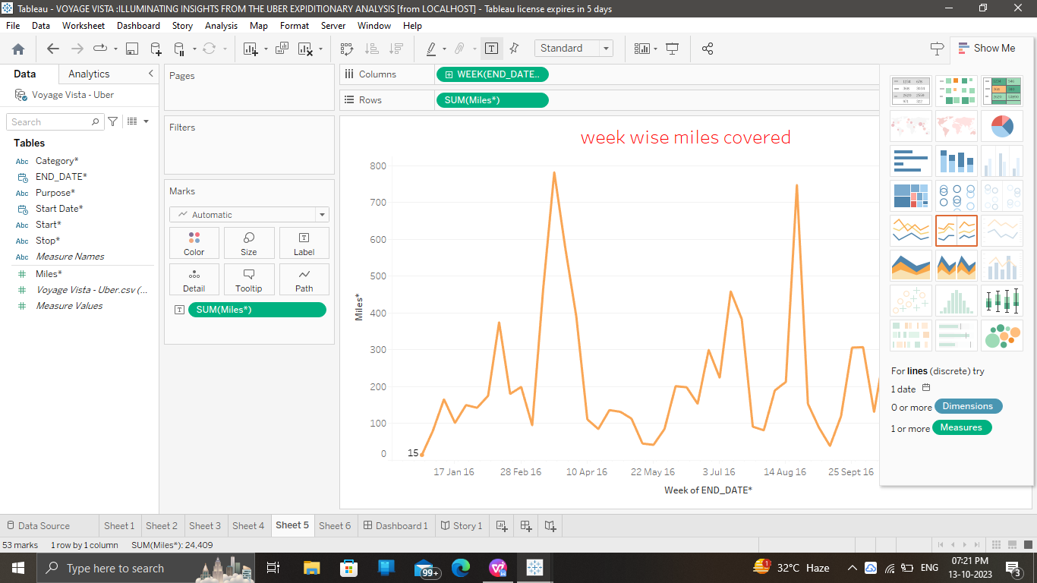

6.Miles of quarter year for UBER

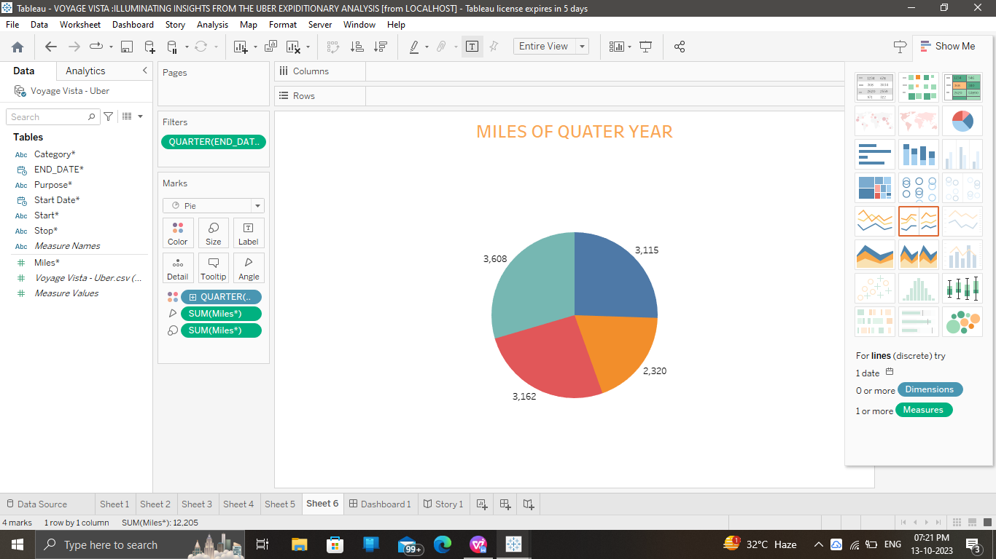

4.DASHBOARD

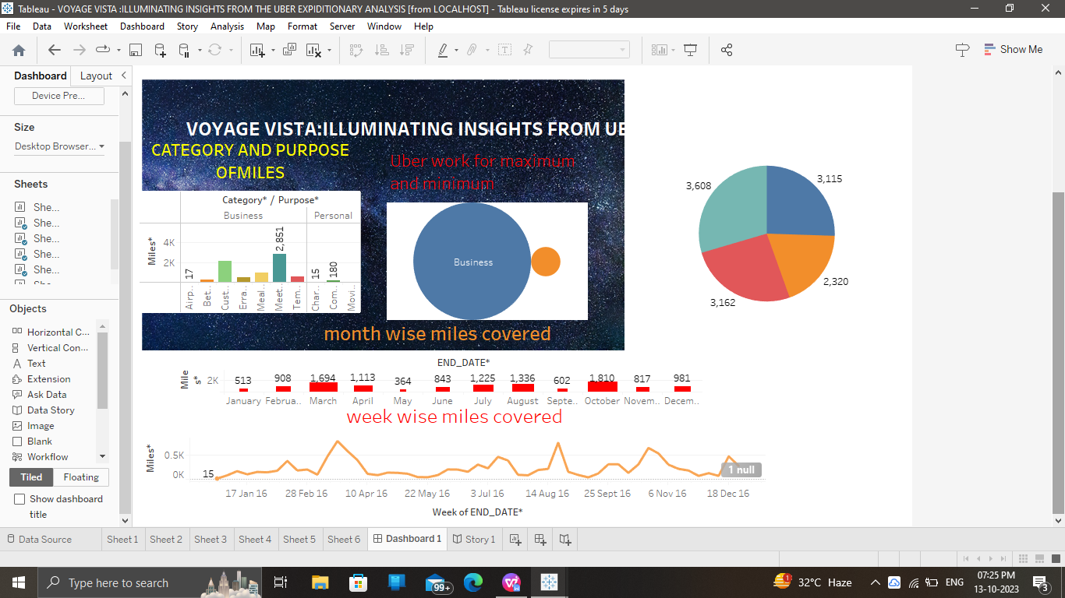

5.STORY

5.1:Revolution : A data driven exploration of UBERS impact in India.

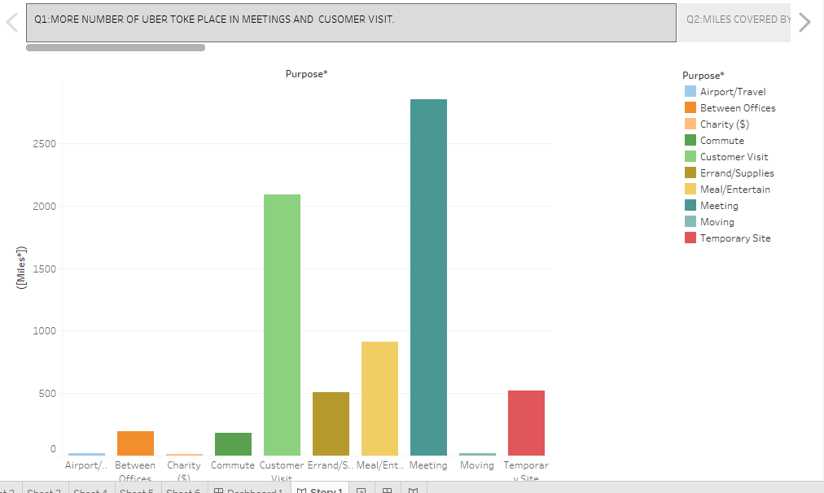

5.2:Revolution : A data driven exploration of UBERS impact in India.

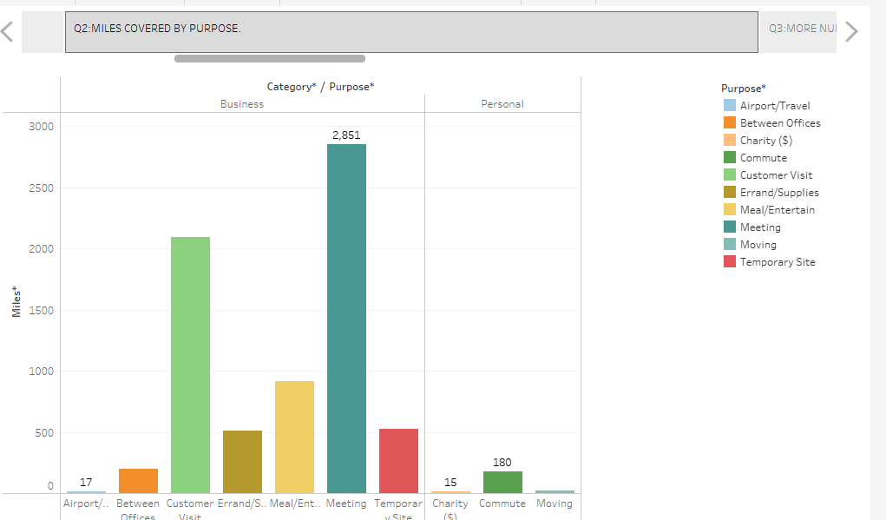

5.3:Revolution : A data driven exploration of UBERS impact in India

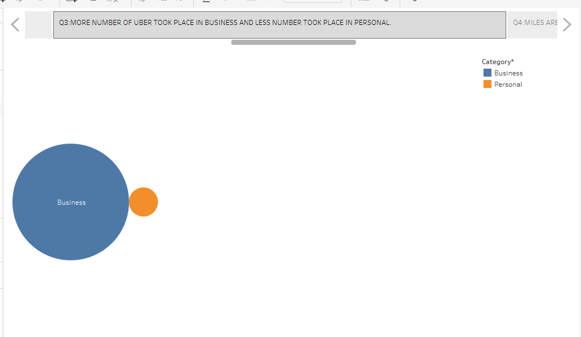

5.4:Revolution : A data driven exploration of UBERS impact in India

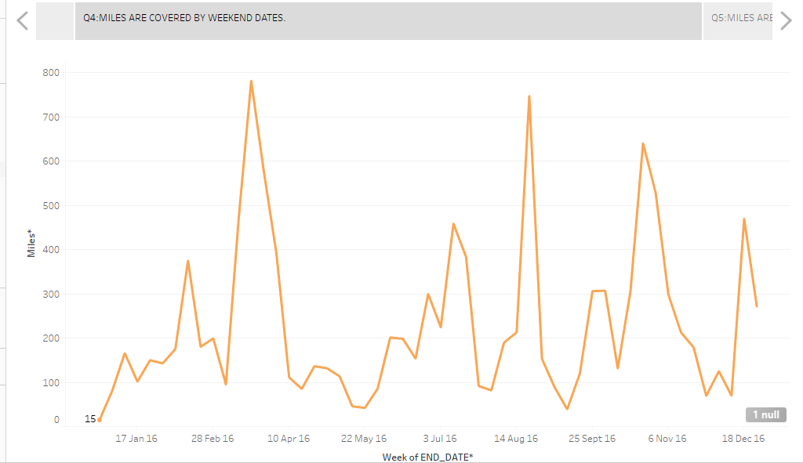

5.5:Revolution : A data driven exploration of UBERS impact in India.

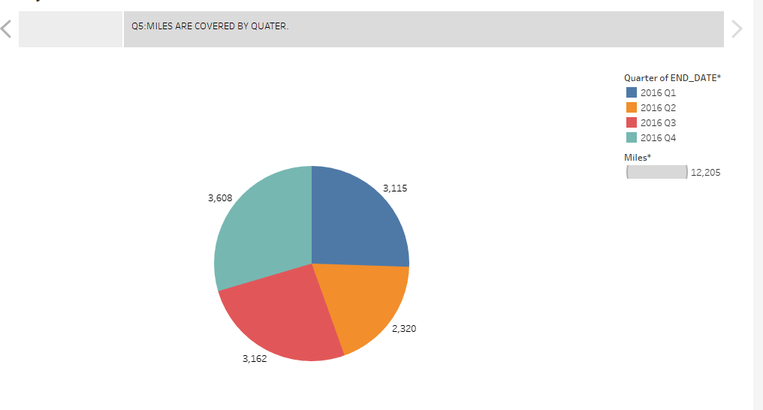

6:Advantages and Disadvantages

6.1:Advantages:

* With Uber, you have security and peace of mind. Also, Uber is cheaper than any other type of rides. Taxi charges fare and the tip, but with Uber everything is included in the price you pay. Uber allow ride sharing also called carpool which makes it cheaper
* Ride-sharing services like Uber have disrupted the taxi and limo industry, Uber has become a prime example of the gig economy at work. Uber's advantages include door-to-door convenience, safety, and reliable quality.

6.2:Disadvantages:

* You have a big responsibility for your passengers.
* Taxi drivers don't make much money.
* You don't have a regular schedule.
* Taxi drivers have to work at nighttime Some cab drivers even have to work on weekends and holidays.
* Can be problematic for your family life.

7.APPLICATIONS:

* By using all these data and analysing the data we have learned the taxi transport situation in India.
* Using tableau we can visualize all the data for easy understanding.
* The Uber app provides convenient and affordable transport in the city.
* Request a ride from 600+ airports and in 10,000+ cities around the world, the Uber app is a great way to make your travel plans stress-free. Request a ride on demand or schedule one ahead of time. FIND A RIDE TO ALMOST ANYWHERE

1. CONCLUTION:

Hereby we understand how to use tableau application and analysing the given data. Using tableau application we can create visualizations for easy understanding.

1. FUTURE SCOPE:

We will give the solution for various problems using data set by tableau software.

Scopes grant permission to various API endpoints for your app. When requesting an access token to use on behalf of a user, your application will specify which scopes it needs and these will be shown to the user during the OAuth flow. It’s best to limit the scopes you need to the bare minimum so that users can feel confident with your app and the amount of data it can access.